**CanKiet**

**(Online Canteen System)**

**A PROJECT REPORT**

**for**

**Mini Project-I (K24MCA18P)**

**Session (2024-25)**

**Submitted by**

**Nilesh Agrahari**

202410116100134

**Nancy Gupta**

202410116100130

**Nishant Raikwar**

202410116100135

**Submitted in partial fulfilment of the**

**Requirements for the Degree of**

**MASTER OF COMPUTER APPLICATION**

**Under the Supervision of**

**Ms. Divya Singhal**

### Assistant Professor



**Submitted to**

**Department Of Computer Applications**

**KIET Group of Institutions, Ghaziabad**

**Uttar Pradesh-201206**

**(december- 2024)**

**CERTIFICATE**

Certified that **Nilesh Agrahari 202410116100134, Nancy Gupta 202410116100130, Nishant Raikwar 202410116100135** has/ have carried out the project work having “**CanKiet (Online Canteen System)**” **(Mini Project-I, K24MCA18P)** for **Master of Computer Application** from Dr. A.P.J. Abdul Kalam Technical University (AKTU) (formerly UPTU), Lucknow under my supervision. The project report embodies original work, and studies are carried out by the student himself/herself and the contents of the project report do not form the basis for the award of any other degree to the candidate or to anybody else from this or any other University/Institution.

**Ms. Divya Singhal Dr. Arun Kr. Tripathi**

**Assistant Professor Dean**

**Department of Computer Applications Department of Computer Applications**

**KIET Group of Institutions, Ghaziabad KIET Group of Institutions, Ghaziabad**

**ABSTRACT**

The **CanKiet** (**Online Canteen System)** is a web-based application designed to streamline the food ordering process within the college campus. This system aims to enhance convenience for students, faculty, and canteen staff by providing a digital platform for menu browsing, order placement, and real-time order tracking. Built using the Django framework, the project incorporates robust features such as user authentication, dynamic menu management, secure payment options, and an intuitive user interface. The system introduces a role-based access model, ensuring seamless management for administrators while offering a user-friendly experience for end-users. Students and faculty can easily view the canteen’s offerings, customize their orders, and provide feedback, fostering an interactive and efficient dining experience. Meanwhile, administrators can track orders, manage inventory, and generate sales reports for better decision-making. By reducing wait times, minimizing manual effort, and promoting digital adoption, the **CanKiet** aligns with the college's vision of incorporating technology into everyday activities. This project not only addresses the operational challenges of traditional canteens but also serves as a stepping stone towards a smart campus ecosystem.

**Keywords:** CanKiet**,** KIET Online Canteen**,** Canteen Management System**,** Django Online Canteen Project, college Canteen Management

**ACKNOWLEDGEMENT**

Success in life is never attained single-handedly. My deepest gratitude goes to my project supervisor, **Ms. Divya Singhal** for her guidance, help, and encouragement throughout my project work. Their enlightening ideas, comments, and suggestions.

Words are not enough to express my gratitude to Dr. Arun Kumar Tripathi, Professor and Dean, Department of Computer Applications, for his insightful comments and administrative help on various occasions.

Fortunately, I have many understanding friends, who have helped me a lot on many critical conditions.

Finally, my sincere thanks go to my family members and all those who have directly and indirectly provided me with moral support and other kind of help. Without their support, completion of this work would not have been possible in time. They keep my life filled with enjoyment and happiness.

**Nilesh Agrahari**

**Nancy Gupta**

**Nishant Raikwar**

**TABLE OF CONTENT**

Certificate ii

Abstract iii

Acknowledgements iv

1. **Introduction 5-12**
   1. Problem in Current System 7
   2. Proposed Solution 8
   3. Functional Requirements 10
   4. Non-Functional Requirements 11
2. **Feasibility Analysis**  **13-15**
3. **Project Objective** **16**
4. **Hardware and Software Requirements** **17**
5. **Project Flow 18-28**
   1. Project Flow 18
   2. Modules 19
   3. ER Diagram 22
   4. Data Flow Diagram 26
6. **Project Outcome** **29-34**
7. **References** **35**

### ****Chapter 1****

**INTRODUCTION**

The **CanKiet** is a web-based application designed to streamline the process of food ordering and management in a college or organizational canteen. With the increasing digitization of services and the growing demand for convenience, traditional manual canteen operations often fall short in providing quick, efficient, and error-free services. This system aims to overcome these challenges by offering a platform where users can browse the menu, place orders, make payments, and receive updates on their order status—all from the comfort of their devices.

**Purpose of the System**

The primary objective of the online canteen system is to enhance customer experience and operational efficiency. It minimizes the dependency on manual processes, reduces waiting times, and improves accuracy in order management. By automating key functions, the system enables canteen staff to focus on preparing and delivering food while ensuring that customers receive a seamless and satisfying service experience.

**Target Audience**

The system is designed for students, faculty, and staff in an educational institution, but its framework can be extended to other settings such as offices, hospitals, and public cafeterias. Its user-friendly interface ensures that people with minimal technical expertise can easily navigate and utilize the platform.

**Key Features**

1. **Menu Display:** Customers can view the menu with detailed descriptions, pricing, and availability status.
2. **Online Ordering:** Users can place orders directly through the website, eliminating the need for physical queues.
3. **Real-Time Updates:** Notifications on order status, such as "Order Received," "In Preparation," and "Ready for Pickup," ensure transparency and convenience.
4. **Payment Integration:** Multiple payment options, including UPI, credit/debit cards, and cash-on-delivery, provide flexibility to users.
5. **Admin Dashboard:** The system includes an admin panel for managing menu items, tracking orders, and monitoring inventory levels.

**Benefits**

* **For Customers:** Saves time, reduces hassle, and ensures better service quality.
* **For Staff:** Simplifies order management, minimizes errors, and reduces workload.
* **For Management:** Enhances operational efficiency and provides insights through data analytics for better decision-making.

**Technological Foundation**

The system leverages robust web development technologies like Django for the backend, HTML, CSS, and JavaScript for the frontend, and MySQL for the database. This technology stack ensures scalability, reliability, and security, making the system capable of handling high volumes of users and transactions.

**Relevance in the Modern Context**

In the current era, where speed and convenience are paramount, an online canteen system aligns perfectly with user expectations. It not only improves the dining experience but also prepares canteens for future expansions by adopting modern technology. By eliminating the inefficiencies of manual processes, this system stands as a practical solution to the evolving needs of today’s fast-paced environments.

The online canteen system thus bridges the gap between traditional operations and digital advancements, creating a win-win scenario for both customers and management.

**1.1 Problem in Existing System**

**Key Problems in the Existing System**

1. **Time-Consuming-Process:**  
    Customers are required to stand in long queues to place orders, make payments, and collect food. This not only wastes time but also leads to customer dissatisfaction, especially during peak hours when the canteen is crowded.
2. **Order-Management-Issues:**  
    Without an integrated system, canteen staff often face difficulties in tracking and managing multiple orders simultaneously. This can result in errors, such as wrong orders being prepared or delays in order fulfillment.
3. **Limited-Customer-Convenience:**  
    Customers cannot browse the menu, check item availability, or place orders in advance. This lack of convenience discourages users from using the canteen, especially when they are pressed for time.
4. **No-Real-Time-Updates:**  
    In the absence of real-time notifications, customers are left guessing the status of their orders. This uncertainty often leads to repeated follow-ups with the staff, causing unnecessary interruptions and inefficiencies.
5. **Dependency-on-Physical-Payments:**  
    Current systems primarily rely on cash or card payments at the counter. There are no options for digital payments or pre-paid systems, which could otherwise expedite the ordering process and reduce cash handling.
6. **Inventory-and-Waste-Management-Challenges:**  
    Basic billing software does not integrate with inventory management, making it difficult for canteen operators to track stock levels in real-time. This can lead to overstocking or wastage of perishable items, impacting the overall profitability of the canteen.
7. **Limited-Data-for-Decision-Making:**  
    The absence of an analytics system means that canteen management has no insights into popular items, peak order times, or customer preferences. This lack of data hinders strategic decision-making and improvement efforts.
8. **Lack-of-Hygiene-and-Social-Distancing:**  
    In crowded canteens, especially in the post-pandemic era, customers are exposed to hygiene risks due to close contact while waiting in queues. An online system could help mitigate such concerns by reducing physical interactions.

**1.2 Proposed System**

The **CanKiet** is designed to address the challenges of the existing manual and billing-based systems. It provides a comprehensive, user-friendly platform to streamline canteen operations, improve customer experience, and enhance overall efficiency. This system leverages modern technology to integrate online ordering, real-time updates, and inventory management into one cohesive platform.

**Key Features of the Proposed System**

1. **Online-Menu-Display:**  
    Customers can browse the menu online, view detailed item descriptions, and check availability in real time.
2. **Online-Ordering-and-Pre-Booking:**  
    Users can place orders through the system and even pre-book meals to avoid long queues and reduce waiting times.
3. **Real-Time-Order-Tracking:**  
    The system provides real-time updates on the order status, such as "Order Received," "In Progress," and "Ready for Pickup," ensuring transparency and customer convenience.
4. **Digital-Payment-Integration:**  
    Multiple payment options, including UPI, credit/debit cards, and wallets, allow customers to make secure and hassle-free transactions.
5. **Admin-Dashboard:**  
    Canteen staff can manage orders, track inventory levels, and update the menu through an intuitive admin panel.
6. **Inventory-Management:**  
    The system tracks stock usage in real-time and alerts staff about low-stock items, ensuring better resource management and minimizing waste.
7. **Data-Analytics:**  
    The system collects and analyzes data on popular items, peak order times, and customer preferences, providing valuable insights for decision-making and improving service quality.
8. **Queue-Reduction:**  
    By enabling customers to order and pay online, the system reduces physical queues at the counter, promoting a smoother workflow and enhancing customer satisfaction.
9. **User-Friendly-Interface:**  
    The platform is designed to be intuitive and accessible, ensuring ease of use for customers and canteen staff alike.
10. **Customization:**  
     The system can be tailored to meet the specific requirements of different canteens, such as integrating meal plans for students or providing discounts for bulk orders.

**Benefits of the Proposed System**

1. **For Customers:**
   * Saves time by eliminating the need to stand in queues.
   * Enhances convenience through online ordering and payment options.
   * Provides transparency with real-time updates on order status.
2. **For Canteen Staff:**
   * Simplifies order and inventory management.
   * Reduces errors and manual workload.
   * Enables efficient resource allocation based on real-time data.
3. **For Management:**
   * Improves profitability by minimizing waste and optimizing inventory.
   * Provides valuable insights for better decision-making.
   * Enhances customer satisfaction, leading to increased sales and brand loyalty.

**1.3 Functional Requirements**

Functional requirements define the core functionalities and features that the system must provide.

1. **User Management:**
   * Users (students, staff, and faculty) should be able to register and log in to the system.
   * Admin should have the ability to manage user accounts.
2. **Menu Management:**
   * The admin should be able to add, update, and delete menu items.
   * Customers should be able to browse the menu with item details such as price, description, and availability.
3. **Order Placement:**
   * Customers should be able to place orders online, specifying the quantity of items.
   * The system should verify item availability before confirming the order.
4. **Real-Time Order Tracking:**
   * Users should receive real-time updates on the status of their orders (e.g., "Order Received," "In Progress," "Ready for Pickup").
5. **Payment Integration:**
   * The system should support multiple payment options, including UPI, credit/debit cards, and wallets.
   * Secure payment processing should be implemented to ensure safe transactions.
6. **Inventory Management:**
   * The admin should be able to monitor stock levels and receive notifications for low-stock items.
7. **Order History:**
   * Customers should have access to their order history for reference.
   * Admin should be able to view all past orders for analytics and record-keeping.
8. **Report Generation:**
   * The system should generate reports on sales, popular items, and peak ordering times for management use.
9. **Search and Filter Options:**
   * Users should be able to search for menu items and filter them based on categories, price, or availability.
10. **Notifications:**
    * The system should notify users of order confirmation, preparation, and completion.

**1.4 Non-Functional Requirements**

Non-functional requirements describe the system's quality attributes, constraints, and performance standards.

1. **Performance:**
   * The system should handle at least 100 concurrent users without performance degradation.
   * Average response time for any user action should not exceed 2 seconds.
2. **Scalability:**
   * The system should be scalable to accommodate increased user traffic during peak hours or special events.
3. **Security:**
   * User data, including payment details, should be encrypted to ensure data confidentiality.
   * The system should prevent unauthorized access using secure authentication mechanisms.
4. **Availability:**
   * The system should have an uptime of at least 99.5%, ensuring high availability for users.
5. **Usability:**
   * The user interface should be intuitive and user-friendly, ensuring ease of navigation for all stakeholders.
6. **Maintainability:**
   * The system should be modular to facilitate easy updates, debugging, and maintenance.
7. **Portability:**
   * The system should be accessible on multiple devices, including desktops, laptops, and mobile devices.
8. **Compliance:**
   * The system should comply with relevant data protection laws and standards for online payment security (e.g., PCI-DSS).
9. **Data Backup and Recovery:**
   * The system should have a data backup mechanism to prevent data loss in case of technical failures.
   * It should also support quick data recovery to minimize downtime.
10. **Reliability:**
    * The system should function consistently under varying conditions, ensuring reliable performance for all users.

**Chapter 2**

### ****Feasibility Analysis****

Feasibility analysis ensures that the proposed online canteen system is viable, achievable, and beneficial. This analysis covers technical, economic, operational, legal, and scheduling aspects.

### ****1. Technical Feasibility****

The technical feasibility assesses whether the necessary technology is available and can support the system's requirements.

* **Technology Stack:** The system will use web technologies such as Django for the backend, HTML, CSS, and JavaScript for the frontend, and MySQL for database management. These technologies are well-documented, widely supported, and capable of handling the expected functionality.
* **System Requirements:** The proposed system requires basic web hosting services and database servers, which are affordable and readily available.
* **Scalability:** The system can scale easily by upgrading the hosting infrastructure to accommodate increased user traffic.

### ****2. Economic Feasibility****

The economic feasibility assesses whether the project is financially viable.

* **Development Cost:** The project requires minimal investment as it utilizes open-source technologies and existing resources.
* **Cost-Benefit Analysis:**
  + **Costs:** Development, hosting, and maintenance costs are manageable and low.
  + **Benefits:** Improved canteen management, reduced waiting times, and increased customer satisfaction will result in higher efficiency and potential revenue growth.
* **ROI (Return on Investment):** The system is expected to recover its costs quickly by streamlining operations and potentially increasing canteen sales through online ordering.

### ****3. Operational Feasibility****

Operational feasibility assesses whether the system can operate effectively and is user-friendly for all stakeholders.

* **Ease of Use:**
  + Customers can easily browse the menu, place orders, and make payments through an intuitive web interface.
  + Canteen staff can efficiently manage orders and inventory through an admin dashboard.
* **Stakeholder Acceptance:**
  + Students, staff, and management are likely to adopt the system due to its convenience and time-saving features.
* **Improved Workflow:** The system will streamline order processing, minimize errors, and improve overall service quality.

### ****4. Legal Feasibility****

Legal feasibility ensures that the system complies with relevant laws and regulations.

* **Data Privacy:** The system will adhere to data protection laws, ensuring secure handling of user data like names, contact details, and payment information.
* **Payment Integration Compliance:** Payment gateways used in the system will comply with financial transaction regulations to ensure secure and legal transactions.

### ****5. Scheduling Feasibility****

Scheduling feasibility evaluates whether the system can be developed and implemented within the stipulated timeframe.

* **Timeline:**
  + Requirements gathering: 2 weeks
  + System design: 2 weeks
  + Development and testing: 6 weeks
  + Deployment: 1 week
* **Resource Availability:** Adequate resources, including skilled developers and necessary tools, are available to complete the project on time.

### ****Chapter 3****

### ****Project Objective****

The **CanKiet** project aims to achieve the following objectives:

1. **Streamline Food Ordering Process:**

Develop a digital platform that allows users to browse the menu, place orders, and make payments online, minimizing the need for physical queues and manual transactions.

2. **Enhance Operational Efficiency:**

Automate order processing, payment collection, and inventory management to reduce manual effort, improve accuracy, and speed up the overall canteen operations.

3. **Optimize Inventory and Reduce Food Wastage:**

Implement real-time tracking and demand forecasting features to manage stock levels more efficiently, helping reduce food wastage and ensure optimal resource utilization.

4. **Improve Customer Experience:**

Provide a user-friendly interface with features such as real-time order tracking, digital payments, and personalized recommendations to enhance customer satisfaction.

5. **Facilitate Secure Transactions:**

Integrate secure and reliable payment gateways to ensure the safety of financial transactions, protecting users' personal and payment data.

6. **Support Scalability and Adaptability:**

Design the system with flexibility in mind, allowing it to scale and adapt to different canteen sizes and settings, such as schools, offices, or institutions.

**Chapter 4**

#### **Hardware and Software Requirements**

**Hardware Requirements:**

* Processor: Intel i5 or higher
* RAM: 8 GB or more
* Storage: 500 GB SSD or higher
* Operating System: Windows 10/11 or Linux

**Software Requirements:**

* Backend: Django Framework (Python)
* Frontend: HTML, CSS, JavaScript (Bootstrap for styling)
* Database: SQLite
* IDE: Visual Studio Code
* Other Tools: Git for version control, Figma for UI design

#### ****Chapter 5****

#### ****5.1 Project Flow****

The project follows an agile development methodology to ensure iterative development and regular feedback incorporation is shown in below Figure 5.1.

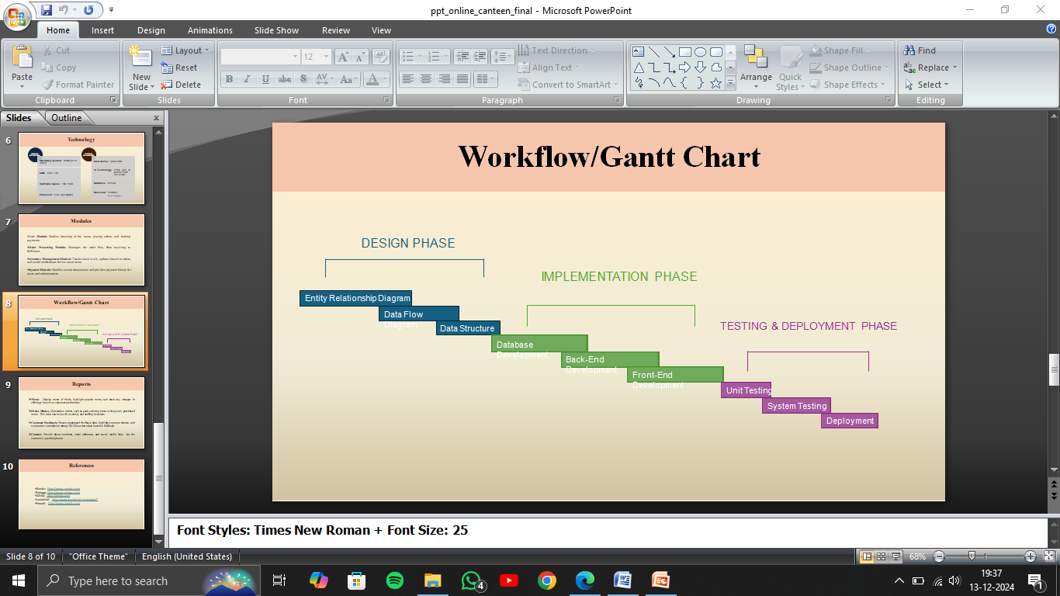

Fig 5.1 Project flow

1. **Requirement Gathering and Analysis:**
   * Identify user needs through surveys and interviews with students, faculty, and canteen staff.
   * Define project scope and features.
2. **System Design:**
   * Develop database schema and application architecture.
   * Design user interface mock-ups for different user roles.
3. **Implementation:**
   * Develop backend functionalities using Django.
   * Integrate frontend templates for responsive design.
   * Implement authentication and role-based access control.
4. **Testing:**
   * Perform unit testing for each module.
   * Conduct integration and usability testing.
5. **Deployment:**
   * Host the application on a server.
   * Provide user training sessions.
6. **Maintenance and Feedback:**
   * Collect user feedback for iterative improvements.

**5.2 Modules of Online Canteen**

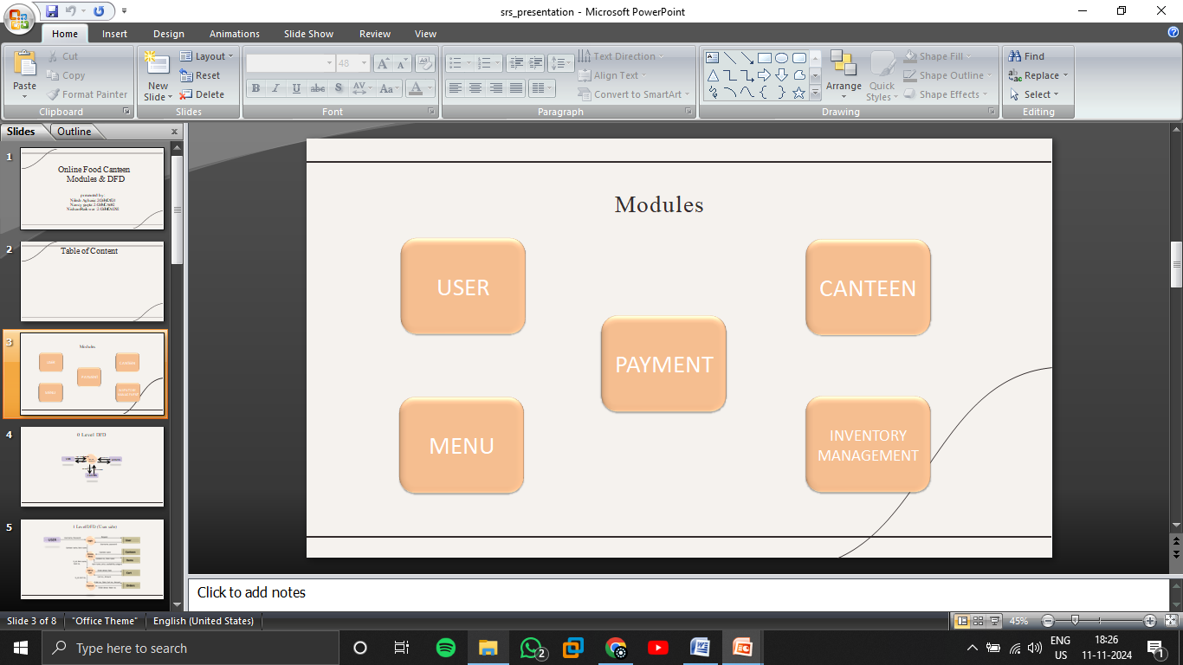

Fig 5.2 Modules

**1. User Module**

**Description:**

This module as shown in Figure 5.2 handles all user interactions with the system, allowing users to browse the menu, place orders, view order history, and manage their profile.

**Features:**

* **User Registration/Login:** Allows users to register and log in with unique credentials.
* **Profile Management:** Enables users to update personal information, view past orders, and manage payment methods.
* **Menu Browsing:** Allows users to browse available items, view details, and add items to their cart.
* **Order Placement:** Users can select items, add to cart, and place orders.
* **Order Tracking:** Provides real-time updates on order status, including order confirmation, preparation, and delivery.

2. **Canteen Module**

**Description**:

This module as shown in Figure 5.2 is designed for canteen staff, allowing them to receive, manage, and fulfill orders.

**Features**:

* **Order Management**: Displays incoming orders, their status, and allows the canteen staff to update the status (e.g., preparing, ready, completed).
* **Menu Management**: Enables staff to update menu items, set daily specials, and remove unavailable items.
* **Preparation Time Estimation**: Allows staff to set estimated preparation times for each item or order.

3. **Admin Module**

**Description:**

The Admin module as shown in Figure 5.2 provides overall control of the system, allowing administrators to manage users, canteen staff, menu items, and system settings.

**Features:**

* **User Management:** Add, edit, or deactivate users and staff accounts, and manage permissions.
* **Canteen Management:** Oversee canteen operations, review performance metrics, and manage canteen staff.
* **Analytics and Reporting:** Access reports on sales, most-ordered items, and peak times to aid in decision-making.
* **System Configuration**: Customize system settings such as business hours, payment options, and notifications.

**4. Order Module**

**Description**

This module as shown in Figure 5.2 handles the entire order process from cart to checkout, ensuring that orders are correctly processed and managed.

**Features**

* **Cart Management**: Allows users to add items to their cart, modify quantities, and view the total cost.
* **Order Confirmation**: Generates a confirmation once the user completes the payment, triggering the order preparation process.
* **Order Status Tracking**: Updates the user on order progress (placed, preparing, ready).
* **Order History:** Stores past orders, allowing users to view or reorder previous items.

5. **Payment Module**

**Description**

This module as shown in Figure 5.2 manages all payment-related processes, ensuring secure transactions between the user and the canteen.

**Features**

* **Payment Gateway Integration**: Supports multiple payment options (credit/debit cards, digital wallets, UPI).
* **Transaction Security**: Encrypts payment details to secure transactions.
* **Payment Confirmation and Receipt Generation**: Confirms successful transactions and generates a digital receipt for the user.
* **Refund Management**: Handles partial or full refunds in case of order cancellations or unavailability of items.

6. **Inventory Management Module**

**Description**

This module as shown in Figure 5.2 allows the canteen to manage stock levels, track item availability, and ensure items are always in supply.

**Features**

* **Stock Management**: Monitors inventory levels, allowing staff to update quantities, and alerts for low stock.
* **Inventory Tracking**: Tracks the usage of ingredients for each order to keep an accurate count of available stock.
* **Supplier Management**: Manages information about suppliers and reorder timelines.

Each module is essential to the system's functionality, ensuring an efficient, reliable, and user-friendly experience for both users and canteen administrators.

**5.3 ER Diagram**

The ER diagram provides in **Fig 5.3** is a structured overview of the entities involved in the online canteen management system and their relationships. The primary entities include USER, CART, ITEMS, ORDERS, and CANTEEN. Each entity has its own attributes, and the relationships between entities show how they interact within the system.

**1. Entities and Their Attributes**

**1.1 User Entity**

* **Attributes**:
  + user id (Primary Key)
  + name
  + phone no
  + branch
  + password

**1.2 Cart Entity**

* **Attributes**:
  + cart no (Primary Key)
  + item no (Foreign Key referencing Item)
  + quantity
  + amount
  + date
  + status
* **Relationships**:
  + A User can have many Cart (1-to-many), meaning a user can have multiple carts.
  + A Cart can contain multiple Items, and multiple items can be added to a single cart (many-to-many relation).

**1.3 Item Entity**

* **Attributes**:
  + Item no (Primary Key)
  + item name
  + price
  + canteen no (Foreign Key referencing Canteen)
  + availability
  + category
* **Relationships**:
  + Items are served in a Canteen, so there's a 1-to-many relationship between Canteen and Item (a canteen can serve multiple items).
  + An Item can be added to multiple Carts (many-to-many relationship).

**1.4 Orders Entity**

* **Attributes**:
  + order no (Primary Key)
  + cart no. (Foreign Key referencing Cart)
  + date
* **Relationships**:
  + A Cart can result in multiple Orders (1-to-many), indicating a cart can be processed into one or more orders.

**1.5 Canteen Entity**

* **Attributes**:
  + canteen no. (Primary Key)
  + canteen name
* **Relationships**:
  + A Canteen can serve multiple Items (1-to-many).
  + There’s a relationship between Canteen and Orders (1-to-many), where a canteen can fulfill many orders.

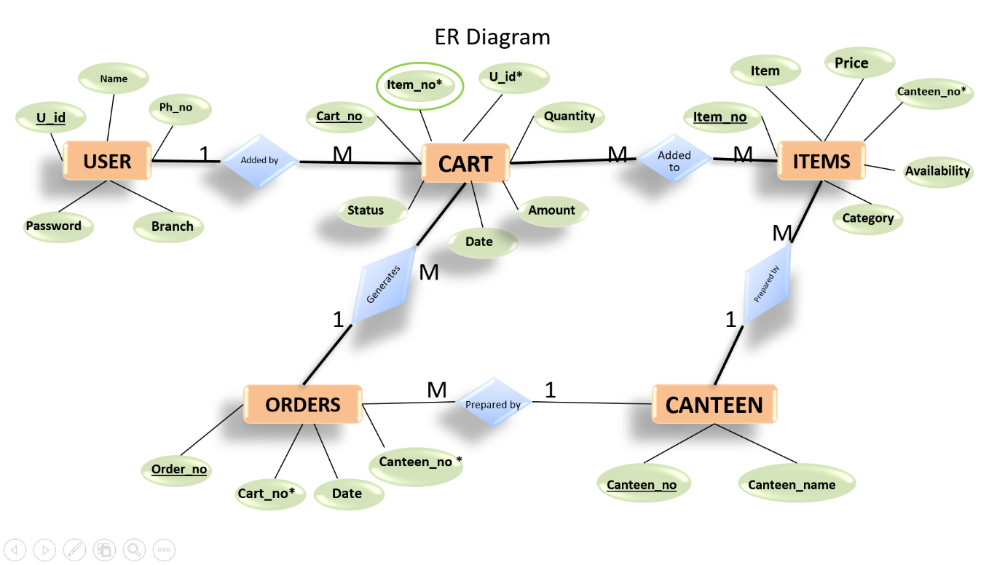

Fig 5.3 Entity Relationship Diagram

**5.4 DFD**

**0 Level:**

The **Zero-Level Data Flow Diagram (DFD)** represented in **Fig 5.4.1** is the highest level of abstraction in the system, providing an overview of the core processes and how the system interacts with external entities. For the **Online Canteen** system, the three primary external entities interacting with the system are **User**, **Admin**, and **Canteen**. Below is the description of the Zero-Level DFD for the Online Canteen system.

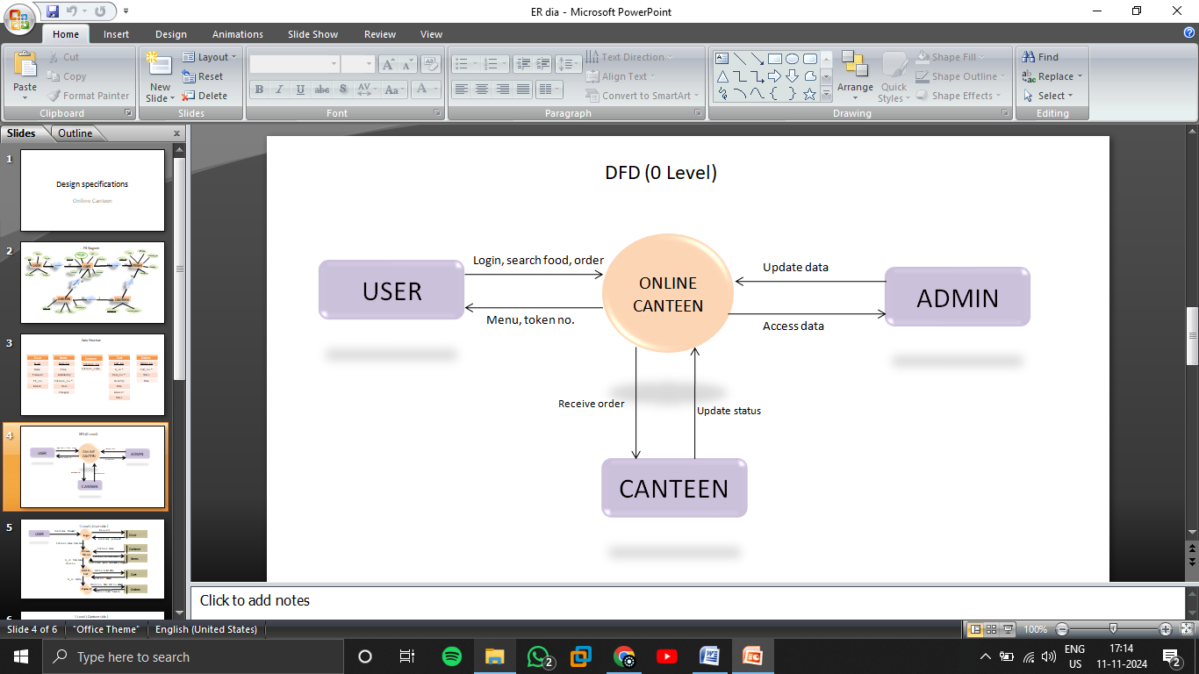

Fig 5.4 Zero level DFD

**Entities:**

1. **User**: The person who interacts with the system to browse the menu, place orders, make payments, and track order status.
2. **Admin**: The administrator who manages users, canteen operations, menu items, and system settings.
3. **Canteen**: The entity representing the canteen staff who manage the preparation and fulfilment of user orders, monitor inventory, and update the status of orders.

**Processes:**

1. **Online Canteen System**: The central system that facilitates all operations for users, admin, and canteen staff. It handles processes like user registration, order placement, payment processing, order tracking, inventory management, and menu updates.

**1 Level:**

The **Level 1 Data Flow Diagram (DFD)** for the **Online Canteen System** breaks down the Zero-level DFD into more detailed processes that describe the interactions between the **User ( Fig 5.4.2 )**, **Canteen ( Fig 5.4.3 )**, and **Admin** entities with the main functional components of the system. This level captures specific functionalities that each entity interacts with, such as ordering, managing the menu, and handling inventory.

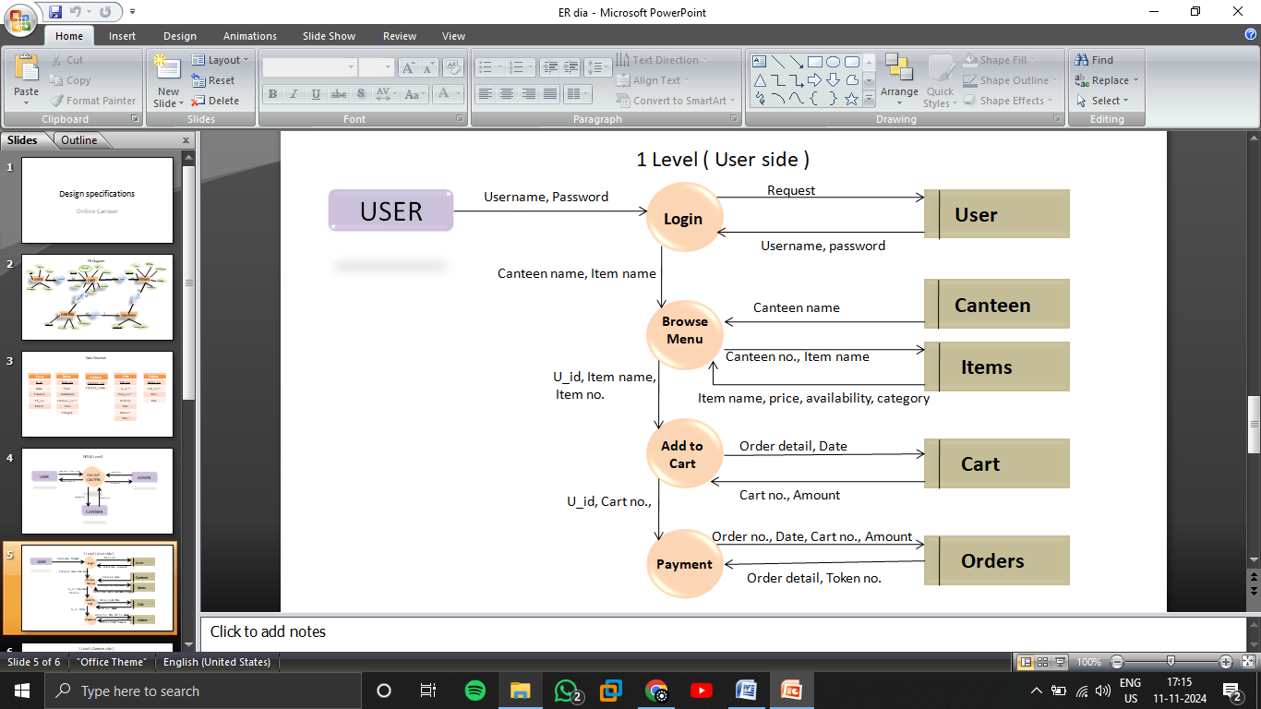

Fig 5.5 User Side DFD

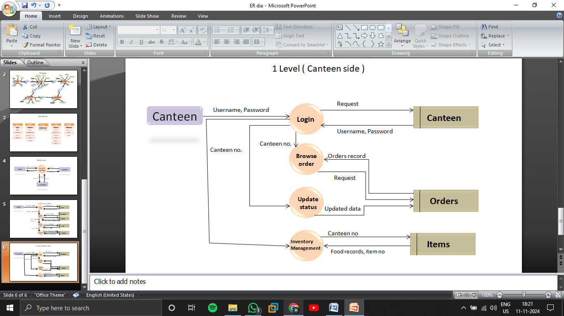

Fig 5.6 Canteen Side DFD

#### ****Chapter 6****

#### ****Project Outcome****

The **CanKiet** is expected to deliver the following outcomes:

* A fully functional web-based platform for canteen operations.
* Enhanced user experience for students and faculty through a simplified ordering process.
* Improved efficiency and reduced operational burden for canteen staff.
* Real-time data analytics for better decision-making by canteen management.
* Increased satisfaction and convenience for all stakeholders.

**Screenshots of final project**

**User interface**

#### Screenshot (3).png

Fig 6.1 Login Page

The CanKiet login page as shown in Figure 6.1 serves as the digital gateway to the CanKiet platform, offering users secure access to its diverse range of services and features. Designed with a focus on user experience and security, the page presents a clean and intuitive interface

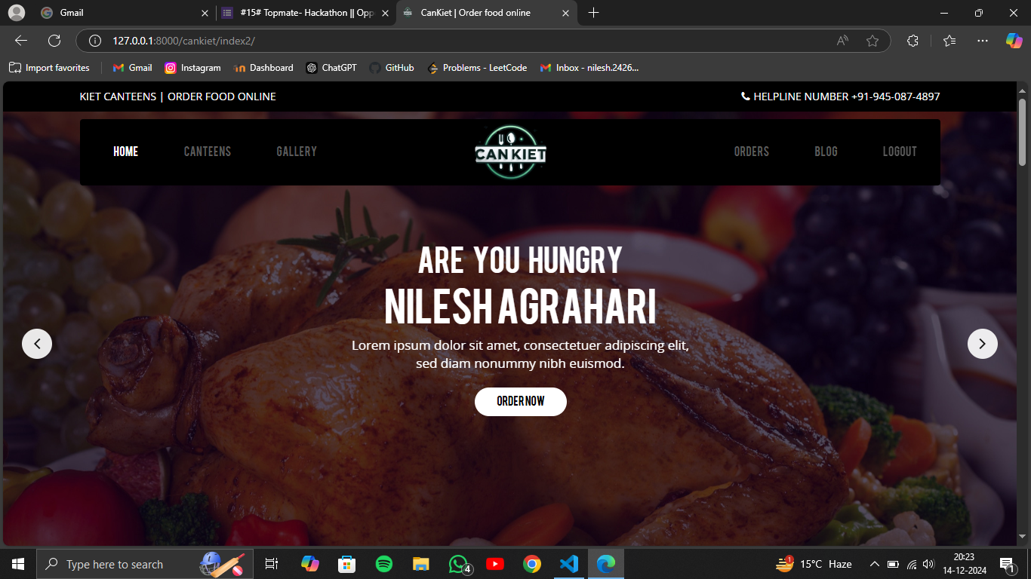

Fig 6.2 Home page

The CanKiet home page as shown in Figure 6.2 is the main landing page for the online canteen service, providing a user-friendly interface for students to explore and order food. The page is designed with a focus on simplicity and ease of use, making it easy for students to navigate and place orders

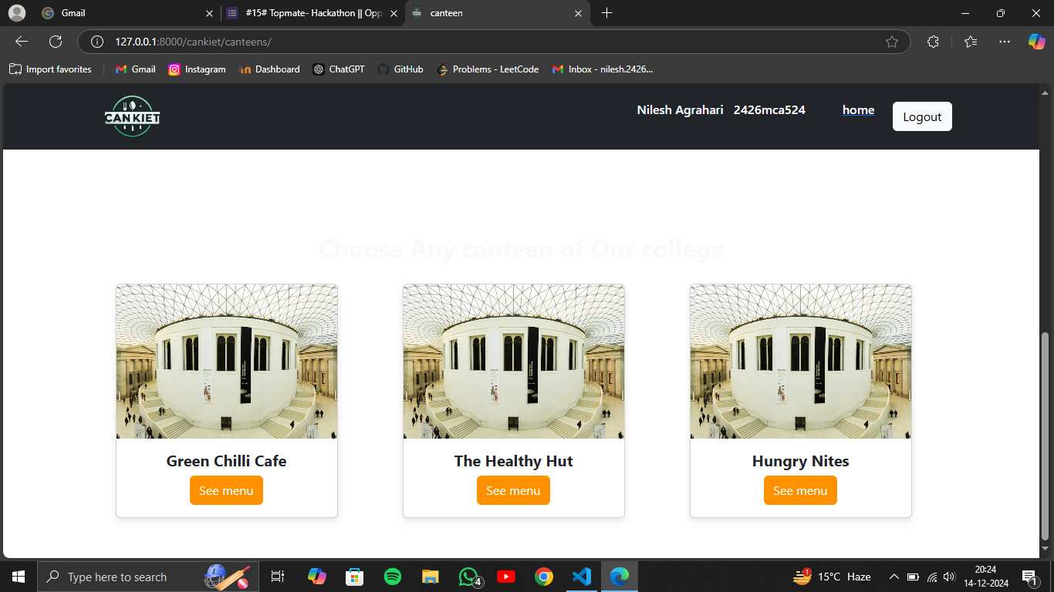

Fig 6.3 Canteen List

The CanKiet canteen selection page as shown in Figure 6.3 provides a user-friendly interface for students to choose from a variety of dining options available on campus. The page displays a list of canteens with their names and images, allowing students to easily identify their preferred choice. Each canteen is accompanied by a "See menu" button, which when clicked, takes the user to a detailed menu page showcasing the available food items and their prices.

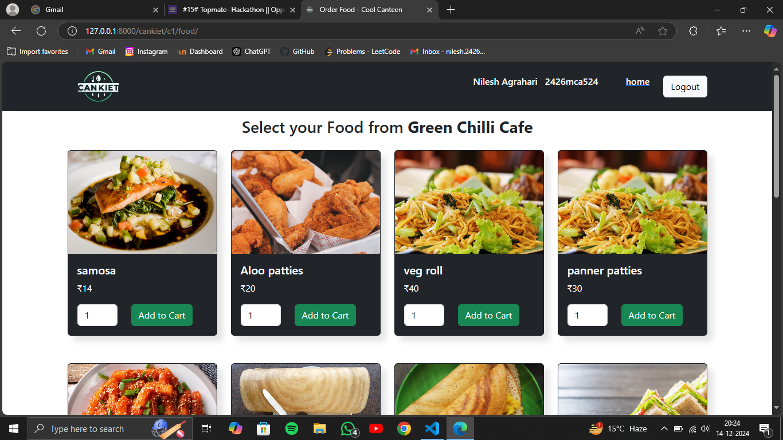

Fig 6.4 Menu Section

The CanKiet item selection page as shown in Figure 6.4 displays a curated selection of food items available from a specific canteen. The page prominently features the name of the selected canteen, allowing users to easily identify the source of the menu items. Each food item is presented with an image, its name, price, and a quantity selector. Users can easily adjust the quantity of each item they wish to order.

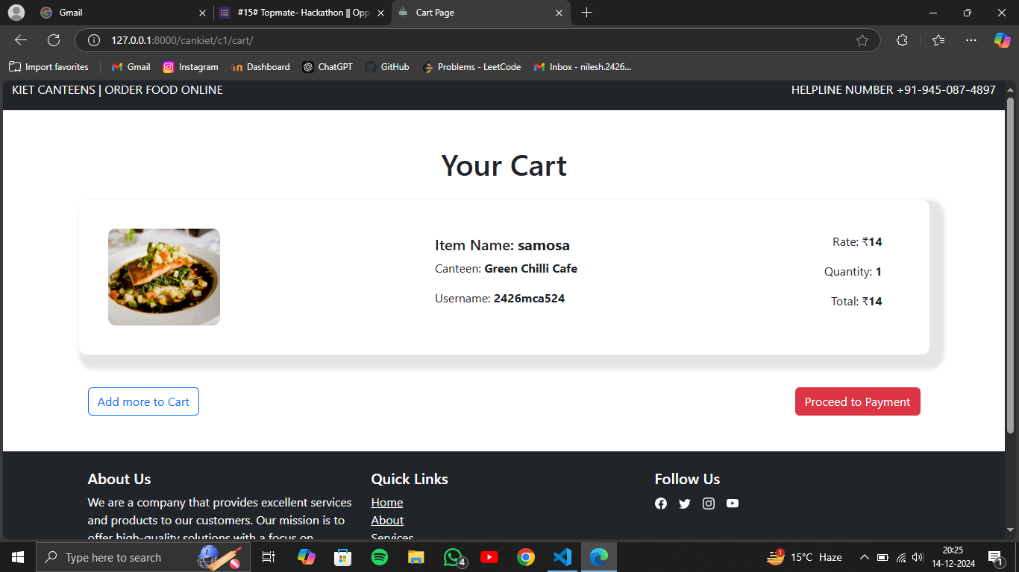

Fig 6.5 Cart page

The CanKiet cart page as shown in Figure 6.5 displays a clear summary of the items a user has added to their order. It includes the name of the item, the canteen it's from, the quantity selected, the price per item, and the total cost. A prominent image of the item is also displayed, providing a visual reference.

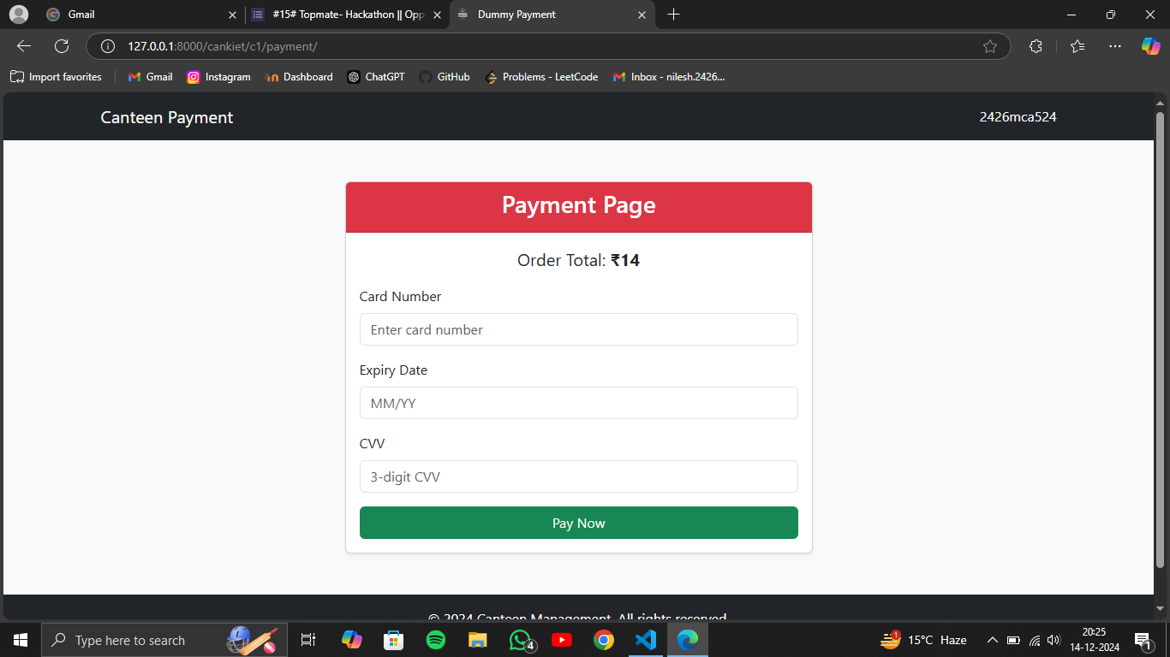

Fig 6.6 Payment page

Figure 6.6 shows the payment page of the CanKiet online canteen. It displays the total order amount and provides fields for the user to enter their card details, including the card number, expiry date, and CVV. Once the user has entered their payment information, they can click on the "Pay Now" button to proceed with the payment.

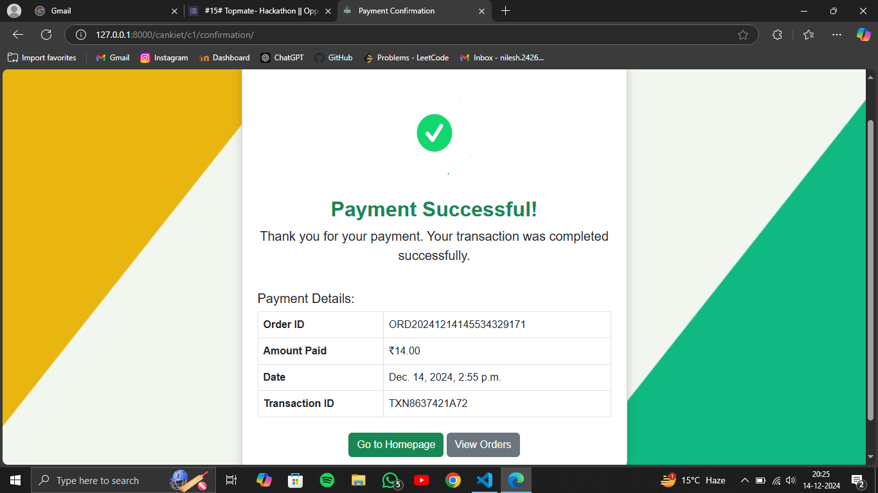

Fig 6.7 Confirmation Page

Figure 6.7 shows the payment confirmation page of the Can Kiet online canteen. It displays a message confirming the success of the payment, along with the order details, including the order ID, amount paid, date of transaction, and transaction ID. The page also provides two buttons: "Go to Homepage" and "View Orders".

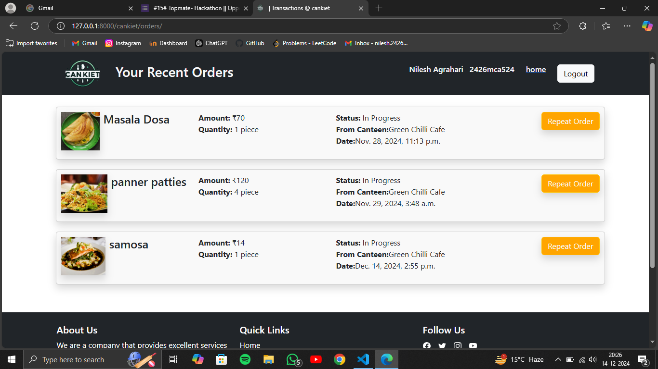

Fig 6.8 Orders Page

The webpage showcases a customer's recent food orders from CanKiet as shown in Figure 6.8, a food delivery service. The page displays a list of the customer's latest orders, each with details such as the item name, quantity, total amount, order status, restaurant name, and order date. Additionally, the page provides essential navigation links like "Home" and "Logout" for easy user interaction.

**Admin Dashboard**

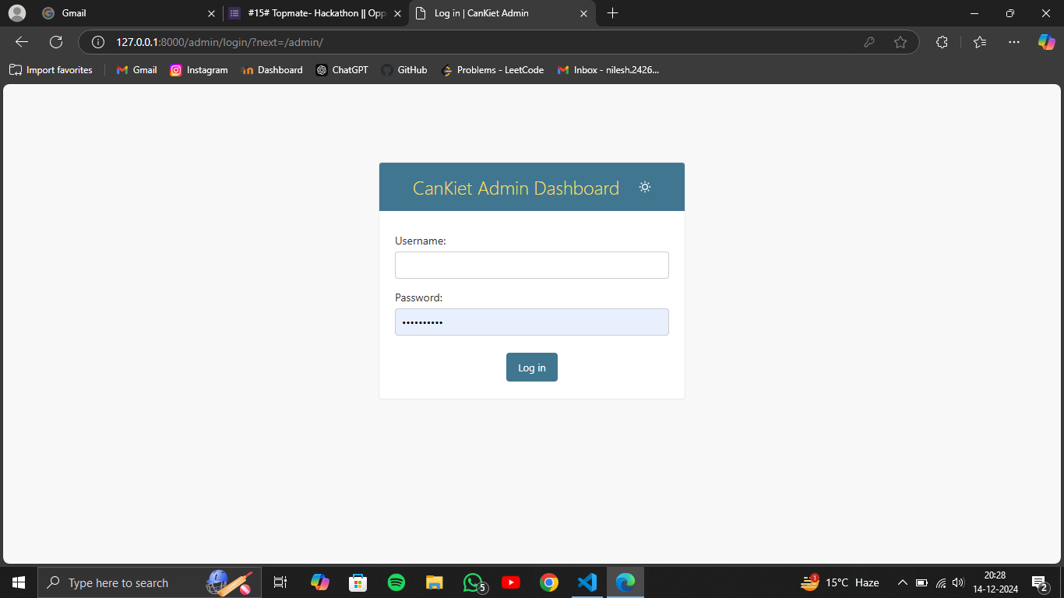

Fig 6.9 Admin login

The Figure 6.9 depicts a login page for the CanKiet Admin Dashboard. It features a straightforward design with a cantered form containing fields for username and password. Below the form, a "Log in" button is placed for authentication purposes. The page's overall aesthetic is clean and professional, with a focus on user experience and security.

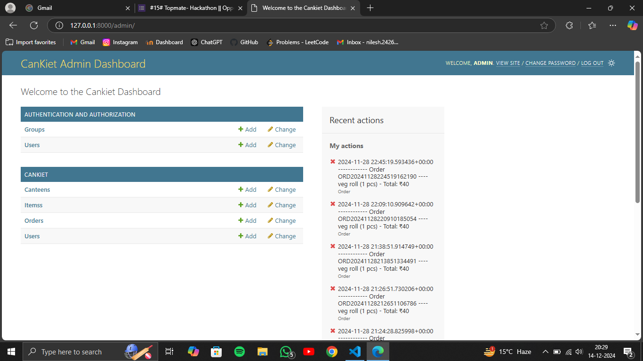

Fig 6.10 Admin Dashboard

The central section of the dashboard as shown in Figure 6.10 focuses on CanKiet-specific features, allowing the admin to manage canteens, items, orders, and users. Each section provides options for adding, changing, and viewing existing data. This comprehensive interface empowers the admin to effectively oversee and manage all aspects of the CanKiet food delivery service.

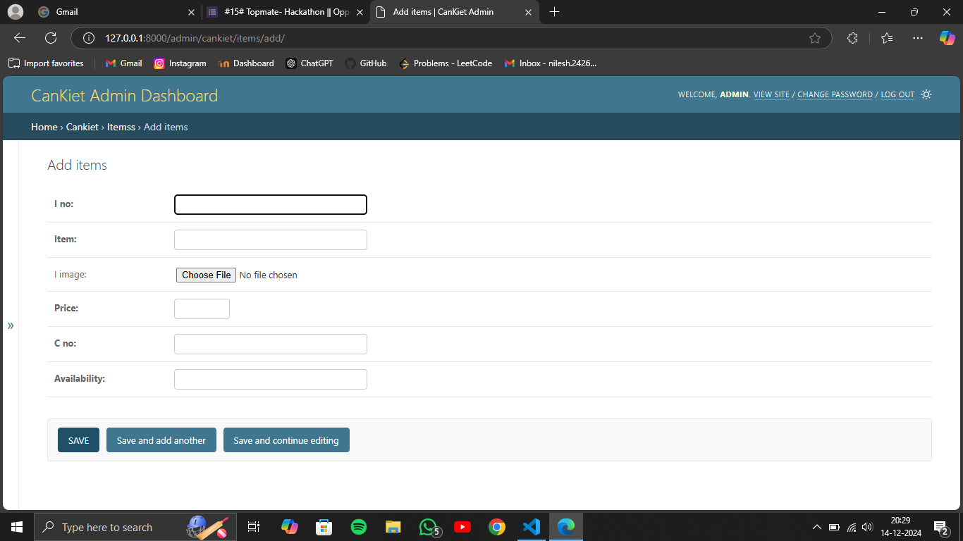

Fig 6.11 Update record

The Figure 6.11 displays the "Add Items" page within the CanKiet Admin Dashboard. This page allows the admin to add new items to the food delivery service's menu.

**REFERENCES**

1. [https://www.djangoproject.com](https://www.djangoproject.com/)
2. [https://getbootstrap.com](https://getbootstrap.com/)
3. Gupta, A., & Kumar, R. (2021). Smart Canteen Management Systems: A Comprehensive Review. International Journal of Computer Applications.
4. Kumar, S. (2020). Using Python and Django for Web Development. Tech Journal.
5. "Swiggy and Zomato Business Models," Business Insider, 2021.